**TECHNICAL REPORT ON UK SMOKING ANALYSIS.**

**Introduction.**

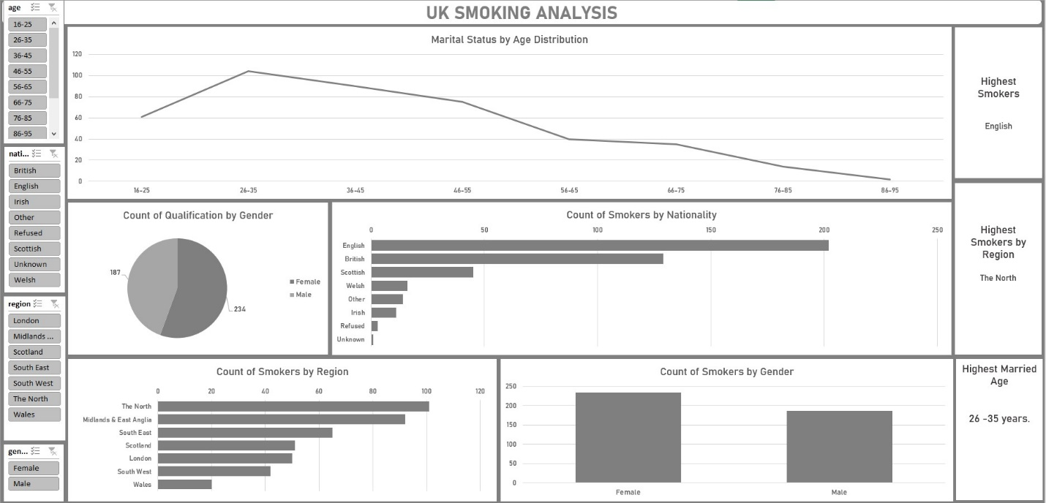

This analysis explores smoking trends across the United Kingdom. By examining factors such as nationality, region, gender, age group, marital status, and educational qualifications, the goal is to identify key patterns and risk groups associated with smoking behavior. Understanding these insights enables public health officials to design targeted interventions that addresses the root causes of smoking and promote healthier lifestyles across the UK.

**Story of the data**

The data is obtained from kaggle.com and telling a story about the smoking habit in the UK and how it affects the population.

**Data collection Process:** This data was sourced from kaggle.com

**Data Splitting**

Category One - Independent variables

1.Gender

2. Nationality

3. Region

Category Two - Dependent values

1. Ethnicity

2. Gross income

3. Age

4. Marital status

5. Highest qualification

6. Smoke

7. Amt weekends

8. Amt weekdays

9. Types

**Industry context:** The data is a HealthCare dataset and its analysis will help to address and prevent smoking in the UK.

**Stakeholders:** Health Organizations.

**Value to the Industry:** The insights will help Health organization provide measure that will reduce smoking among UK population.

**Pre-Analysis**

**Questions**

What is the count of smokers by region?

What is count of qualification by Gender?

Which Nationality has the highest smoking rate?

Count of smokers by Gender.

What is the marital status by age distribution?

**Insights and Observation**

1. English nationals represent the highest number of smokers, followed by British and Scottish. The least represented are Irish, Welsh, and other groups.

2. Smokers by Region: The North has the highest number of smokers, followed by Midlands & East Anglia and South East. Wales and South West have the lowest smoking rate.

3. Smoking is more among females than males in the UK.

4.The 26–35 age group has the highest rate of marriage, implying lifestyle stability or transitional life stages.

5. More reportedly have qualification than the female. This may relate to workforce participation.

**Recommendations**

1. Targeted Health Campaigns: Focus on regions like The North with tailored anti-smoking messages. Use community-based programs to put an end to smoking, especially in high-smoking zones.

2. Youth Prevention Programs: Since the 26–35 age group shows high smoking and marital engagement, programs should address stress management, lifestyle, and family planning education.

3. Develop female-centric smoking cessation support, such as maternal health programs.

4. Educate lower-qualification populations about health risks of smoking. Include smoking information in vocational and adult education curricula in schools and religion centers.

5. Customize communication for dominant smoking nationalities.

**DASHBOARD**



**Conclusion.**

This analysis of UK smoking trends reveals clear patterns across nationality, region, gender, age, and educational background. High smoking prevalence in specific regions and among certain demographics highlights the need for tailored public health interventions. By implementing targeted, culturally aware, and education-driven strategies, stakeholders can more effectively reduce smoking rates and improve population health outcomes. Continued data monitoring and adaptive program design will be essential to ensure sustained progress and equitable impact across all communities.